**SQL Server Assessment**

create table Bus(routeno int primary key,source nvarchar(20) not null,destination nvarchar(20) not null);

create table passenger(pid int primary key,pname nvarchar(20) not null,yob int,gender nvarchar(20) not null);

create table book_ticket(pid int foreign key references passenger,routeno int foreign key references bus,journey_date date,seat_no int not null);

Q1 Ans: select source ,destination from bus where routeno=99;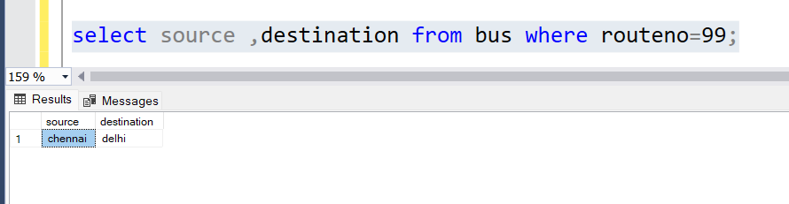

Q2 Ans:

select b.pid passengerid

from bus p full outer join book_ticket b

on p.routeno=b.routeno

where p.source='mumbai' and p.destination='chennai';

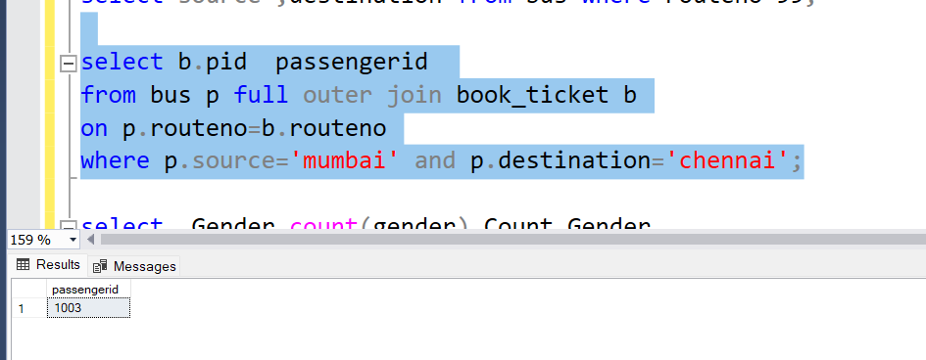

Q3 Ans: select Gender,count(gender) Count_Gender

from passenger

group by gender;

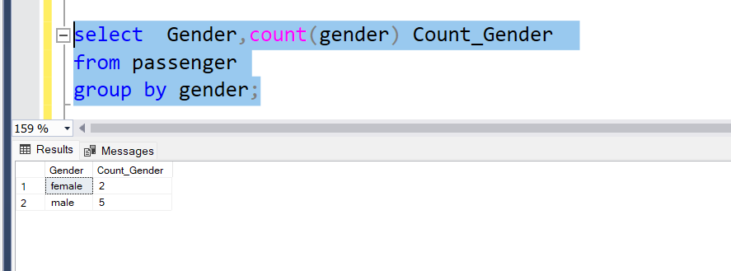

Q4 Ans: select b.routeno,b.source,b.destination

from bus b left join book_ticket t

on b.routeno=t.routeno

where journey_date='7.6.2022';

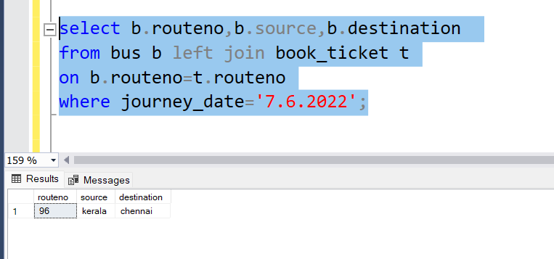

Q5 Ans: CREATE PROCEDURE uds_passenger_details

AS

BEGIN

SET NOCOUNT ON;

-- Insert statements for procedure here

SELECT * from passenger where yob=1974

END

GO

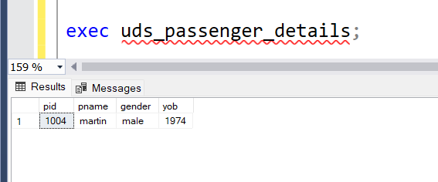

Q6 Ans: CREATE FUNCTION udf_display_city ()

RETURNS TABLE

AS

RETURN

(

SELECT source from bus where routeno=6

)

GO

